Cloud Firewall

☁️ What is a Cloud Firewall?
# Source: Chatgpt (GPT‑5 Mini) at [12/18/2025]
A Cloud Firewall (also called a Firewall-as-a-Service, or FWaaS) is a cloud-based network security solution that filters and controls traffic to and from your cloud infrastructure, applications, and endpoints — without requiring a physical device.
✅ A Cloud Firewall delivers firewall functionality over the internet, making it scalable, centralized, and ideal for protecting cloud-hosted resources and remote users.

🌐 Where It's Used
# Source: Chatgpt (GPT‑5 Mini) at [12/18/2025]
Cloud firewalls are used to protect:
- 🌍 Cloud servers (AWS, Azure, Google Cloud)
- 🧑‍💻 Remote or hybrid users
- 🏢 Branch offices
- 🌐 Web applications
- ☁️ SaaS platforms

🧱 How It Works
# Source: Chatgpt (GPT‑5 Mini) at [12/18/2025]
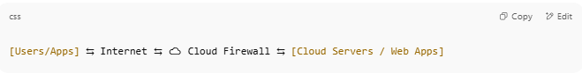
[Users/Apps] ⇆ Internet ⇆ ☁️ Cloud Firewall ⇆ [Cloud Servers / Web Apps]

- Your network traffic is routed through the cloud firewall
- It inspects, filters, and logs based on security policies
- Only safe traffic is allowed to reach your cloud resources

🔧 Key Features of a Cloud Firewall
# Source: Chatgpt (GPT‑5 Mini) at [12/18/2025]
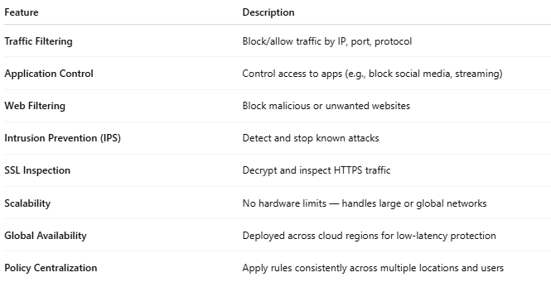

Feature | Description
Traffic Filtering | Block/allow traffic by IP, port, protocol
Application Control | Control access to apps (e.g., block social media, streaming)
Web Filtering | Block malicious or unwanted websites
Intrusion Prevention (IPS) | Detect and stop known attacks
SSL Inspection | Decrypt and inspect HTTPS traffic
Scalability | No hardware limits — handles large or global networks
Global Availability | Deployed across cloud regions for low-latency protection
Policy Centralization | Apply rules consistently across multiple locations and users

🆚 Cloud Firewall vs Traditional Firewall
# Source: Chatgpt (GPT‑5 Mini) at [12/18/2025]
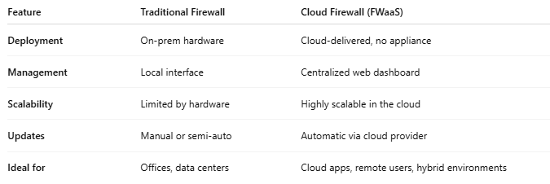

Feature | Traditional Firewall | Cloud Firewall (FWaaS)
Deployment | On-prem hardware | Cloud-delivered, no appliance
Management | Local interface | Centralized web dashboard
Scalability | Limited by hardware | Highly scalable in the cloud
Updates | Manual or semi-auto | Automatic via cloud provider
Ideal for | Offices, data centers | Cloud apps, remote users, hybrid environments

✅ Pros
# Source: Chatgpt (GPT‑5 Mini) at [12/18/2025]
- ✅ No hardware to install or maintain
- ✅ Works anywhere with an internet connection
- ✅ Scales easily as your business grows
- ✅ Ideal for multi-cloud and remote workforces
- ✅ Real-time updates and threat intelligence

❌ Cons
# Source: Chatgpt (GPT‑5 Mini) at [12/18/2025]
- ❌ May add slight latency (due to rerouting traffic through the cloud)
- ❌ Requires trust in the provider’s infrastructure and uptime
- ❌ Less control over physical routing or internal inspection

🏷️ Popular Cloud Firewall Providers
# Source: Chatgpt (GPT‑5 Mini) at [12/18/2025]
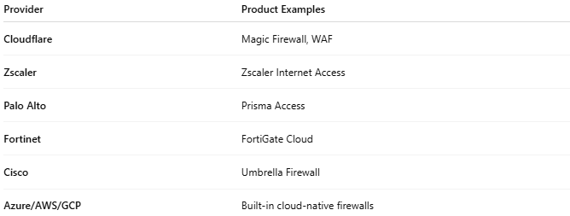

Provider | Product Examples
Cloudflare | Magic Firewall, WAF
Zscaler | Zscaler Internet Access
Palo Alto | Prisma Access
Fortinet | FortiGate Cloud
Cisco | Umbrella Firewall
Azure/AWS/GCP | Built-in cloud-native firewalls

📌 Summary
# Source: Chatgpt (GPT‑5 Mini) at [12/18/2025]
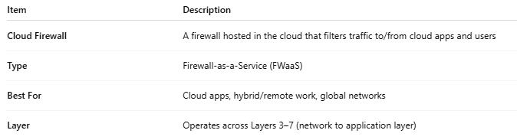

Item | Description
Cloud Firewall | A firewall hosted in the cloud that filters traffic to/from cloud apps and users
Type | Firewall-as-a-Service (FWaaS)
Best For | Cloud apps, hybrid/remote work, global networks
Layer | Operates across Layers 3–7 (network to application layer)

